Sequential Search

#include <iostream>

#define max 100

using namespace std;

int n, c, arr[max], key;

class Sequential

{

public:

    // Function to input array elements from the user

    void input()

    {

        cout << "Enter how many elements you want to store ";

        cin >> n;

        for (int i = 0; i < n; i++)

        {

            cout << "Enter the data for " << i << " Position ";

            cin >> arr[i];

        }

    }

    // Function to display choice options

    void choice()

    {

        cout << "Array:- ";

        for (int e = 0; e < n; e++) // Display the array

        {

            cout << arr[e] << " ";

        }

        cout << endl;

        cout << "Make your Choice. " << endl;

        cout << "1.) Search a Key. " << endl;

        cout << "2.) Exit. " << endl;

        cin >> c;

        // If user doesn't choose to exit, call search function

        if (c != 2)

        {

            search();

        }

    }

    // Function to search for a key in the array

    void search()

    {

        cout << "Enter the key you want to search. " << endl;

        cin >> key;

        int pos = -1;

        for (int i = 0; i < n; i++)

        {

            // If key is found, store its index in pos and break out of loop

            if (key == arr[i])

            {

                pos = i;

                break;

            }

        }

        // If pos is -1, key is not found, insert it at the end of the array

        if (pos == -1)

        {

            cout << "Element " << key << " is not found\n" << "\n";

            // Add the key to the end of the array and increment the size

            arr[n] = key;

            n++;

            cout << "Key is Inserted at the end for the Array" << endl;

            // Display the updated array

            cout << " New Array:- ";

            for (int e = 0; e < n + 1; e++)

            {

                cout << arr[e] << " ";

            }

            cout << endl;

        }

        // If key is found, display the index

        else

        {

            cout << "Element " << key << " is found at index " << pos << "\n" << '\n';

        }

    }

};

int main()

{

    Sequential s;

    s.input();

    do

    {

        s.choice();

    } while (c == 1);

    return 0;

}

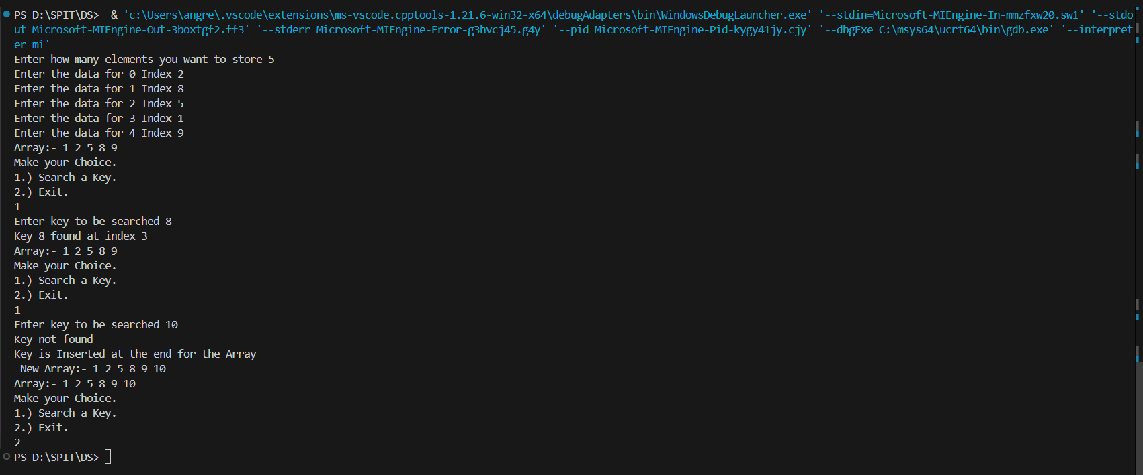

Binary Search